To Supply Leftover Food To Poor

COLLEGE NAME : Sree Narayana Guru College

KG – Chavadi Coimbatore

COLLEGE ID: BRU36

TEAM ID: NM2025TMID26541

TEAM SIZE: 5

TEAM LEADER: MITHUSHA C S

Email ID : [mithush53.shivakumar@gmail.com](mailto:mithush53.shivakumar@gmail.com)

TEAM MEMBER 1: LAKSHMI DEVI D

Email ID : [lakshmidmeenu@gmail.com](mailto:lakshmidmeenu@gmail.com)

TEAM MEMBER 2: MOHAMMED THOUHEED M

Email ID : [thouheedthouheed779@gmail.com](mailto:thouheedthouheed779@gmail.com)

TEAM MEMBER 3: MUHSINA P K

Email ID : [shinuttyshinuzz@gmail.com](mailto:shinuttyshinuzz@gmail.com)

TEAM MEMBER 4 : NAYANA N

Email ID : [n83335012@gmail.com](mailto:n83335012@gmail.com)

**INTRODUCTION**

* 1. **Project overview**

**Utilizing Salesforce, our project streamlines surplus food collection and distribution to the needy, ensuring efficiency and transparency.**

**DEVELOPMENT PHASE**

**Create a Developer Account then Account Activation** <https://developer.salesforce.com/signup>

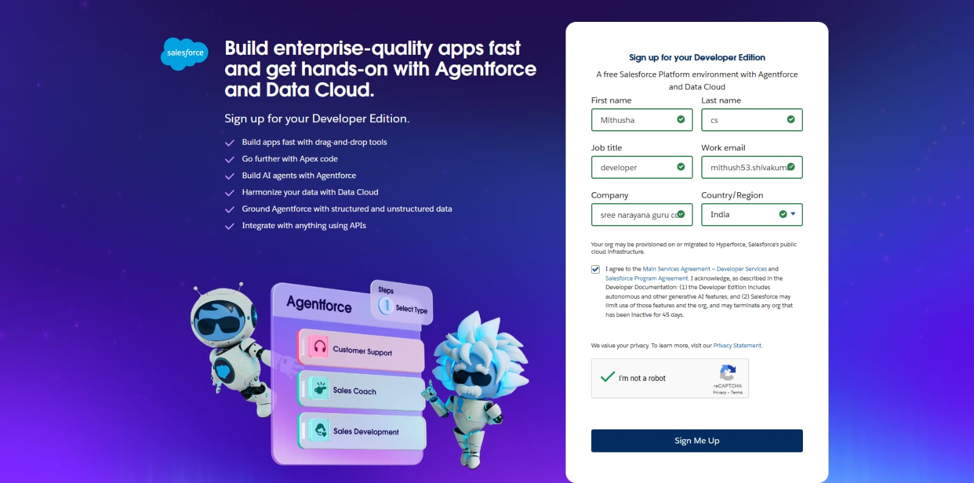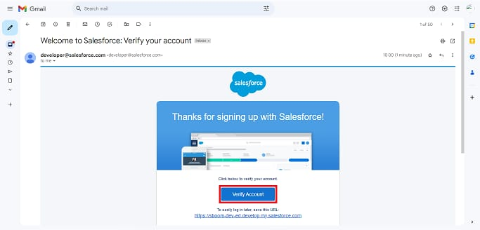

Create Object : Venue, Drop of point, Task, Volunteer, Execution Details

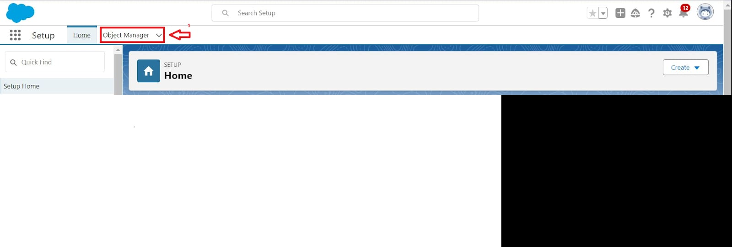

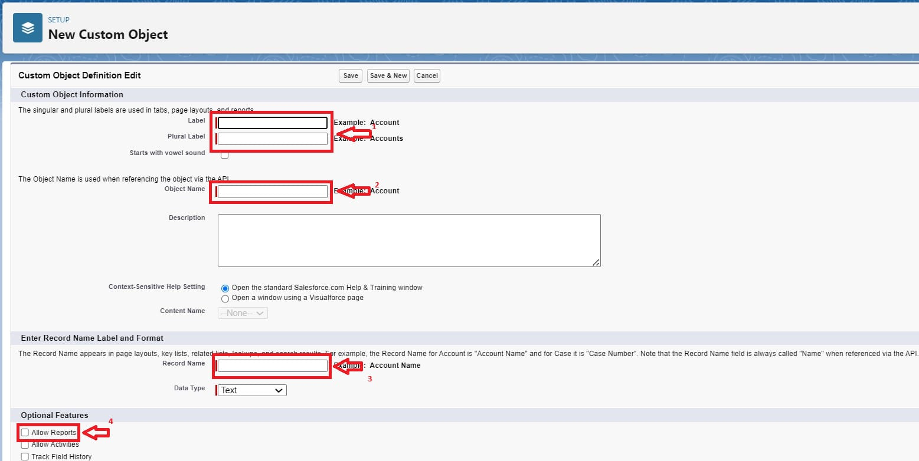

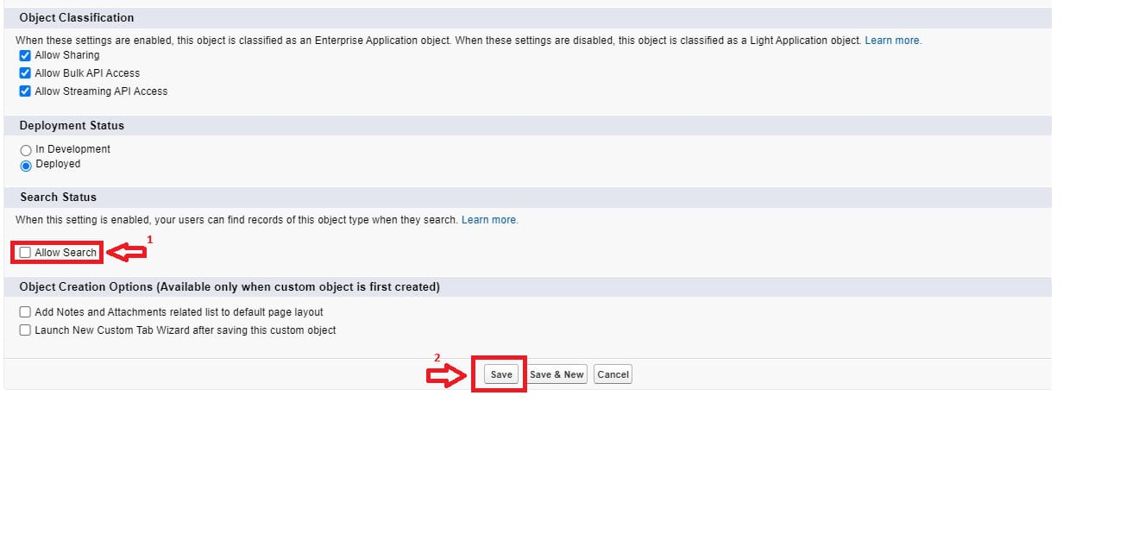

Create Tabs : Custom Tab, Remaining Tabs

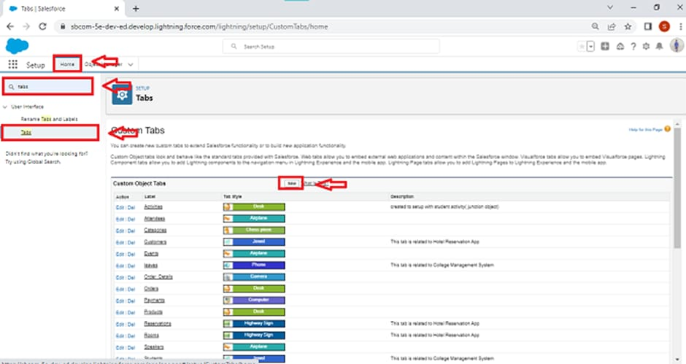

Create The Lightning App: create a Lightning App

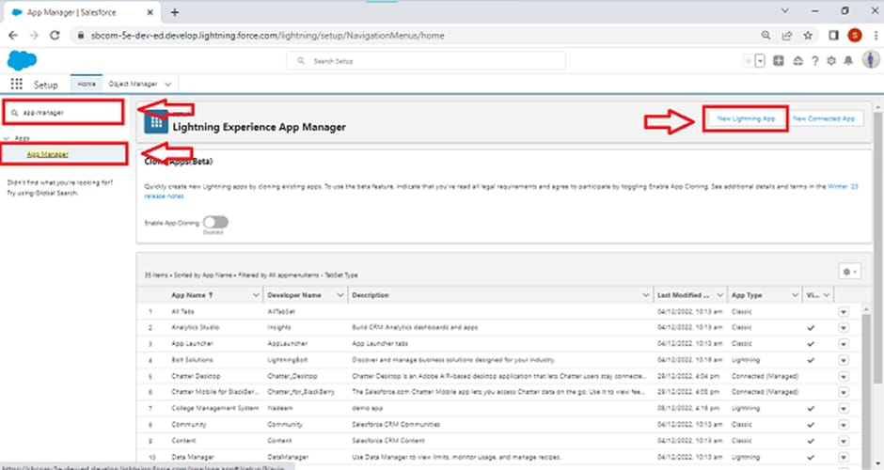

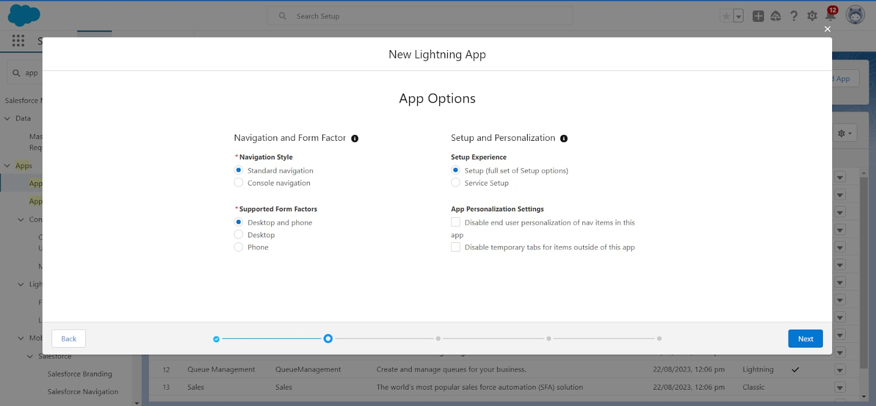

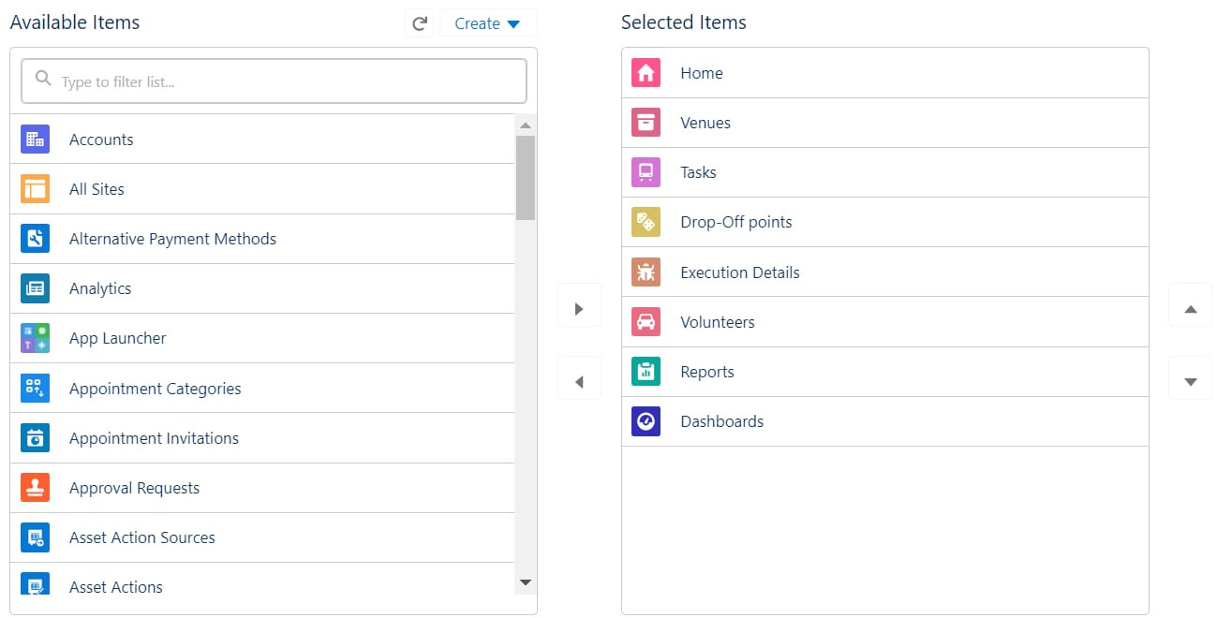

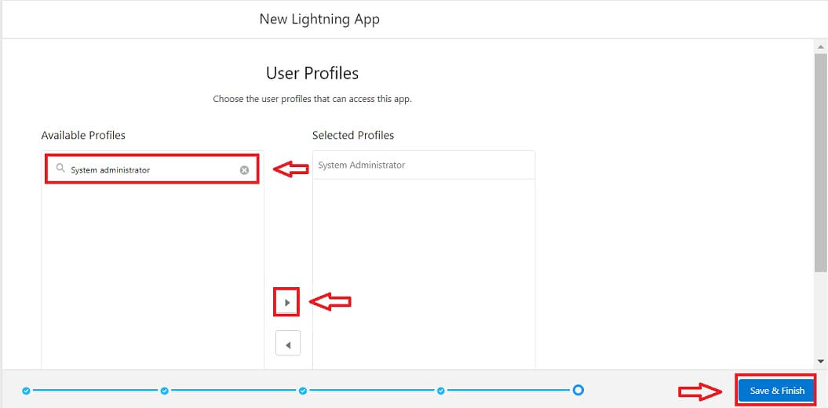

Field: Creation of Relationship fields in objects, fields for the Venue object, fields for the Drop-Off point object,fields for the Task object, fields for the Volunteer object,fields for the Execution Details object.

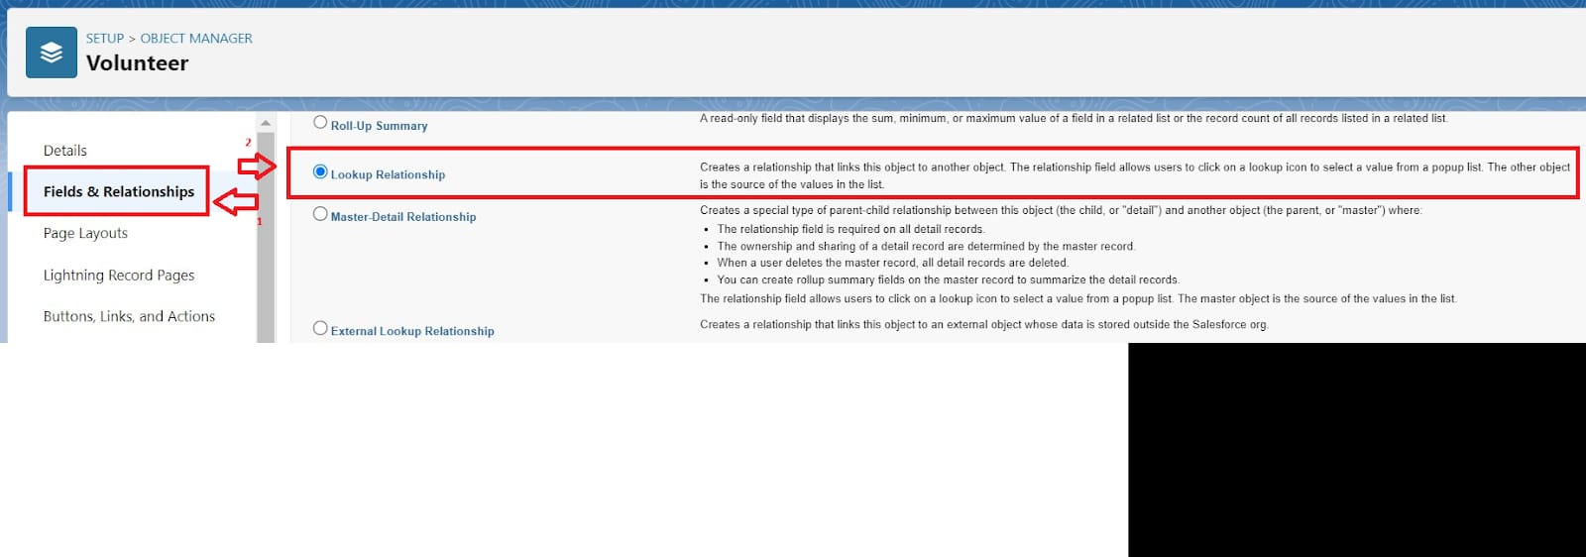

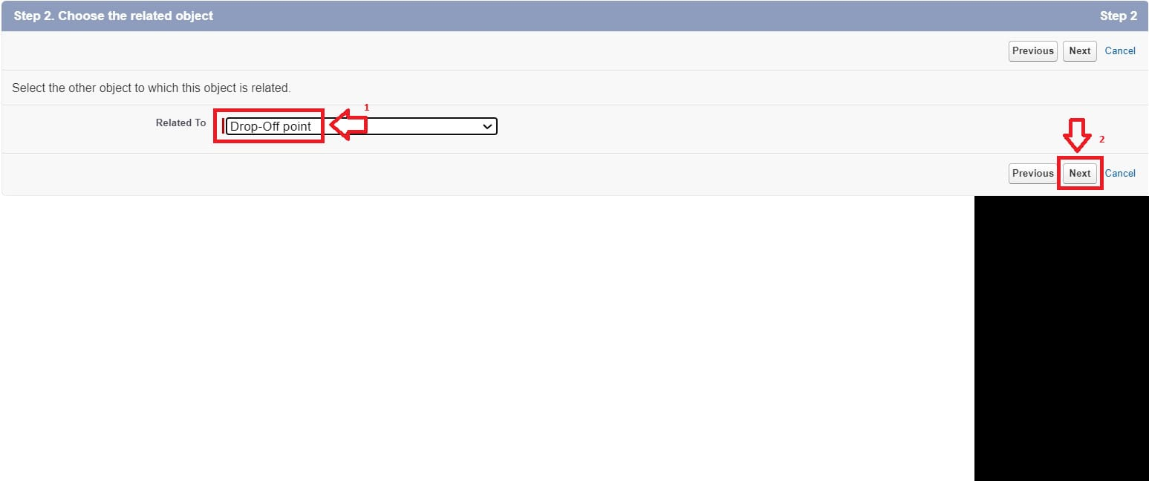

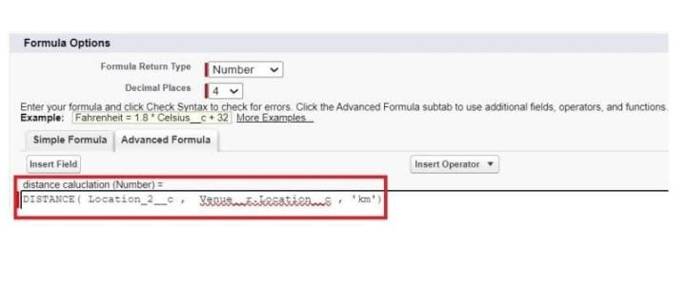

Flows: create Flow to create a record in Venue object.

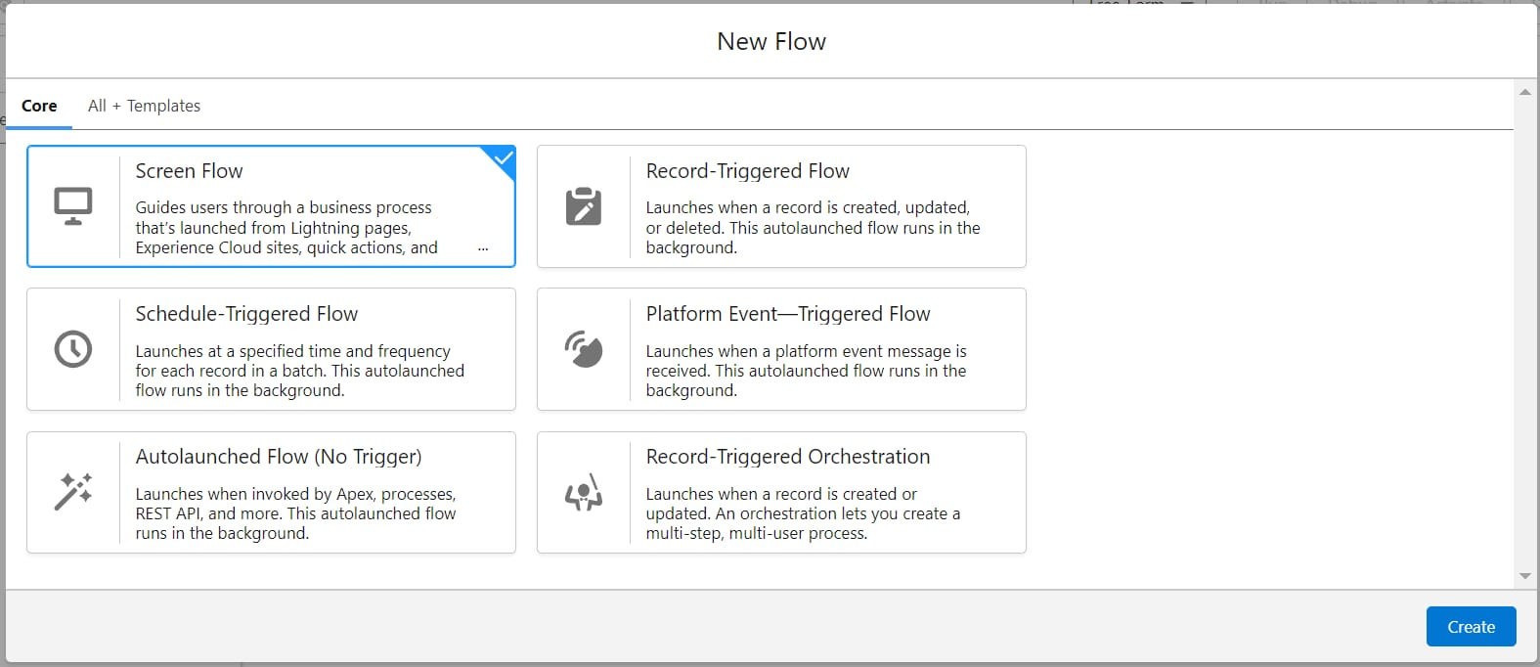

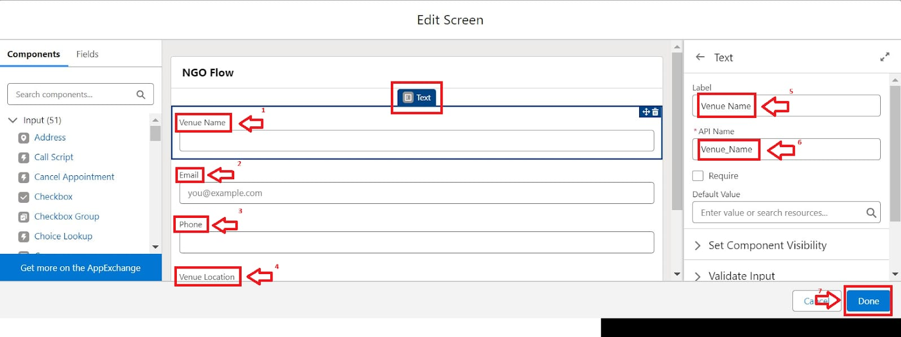

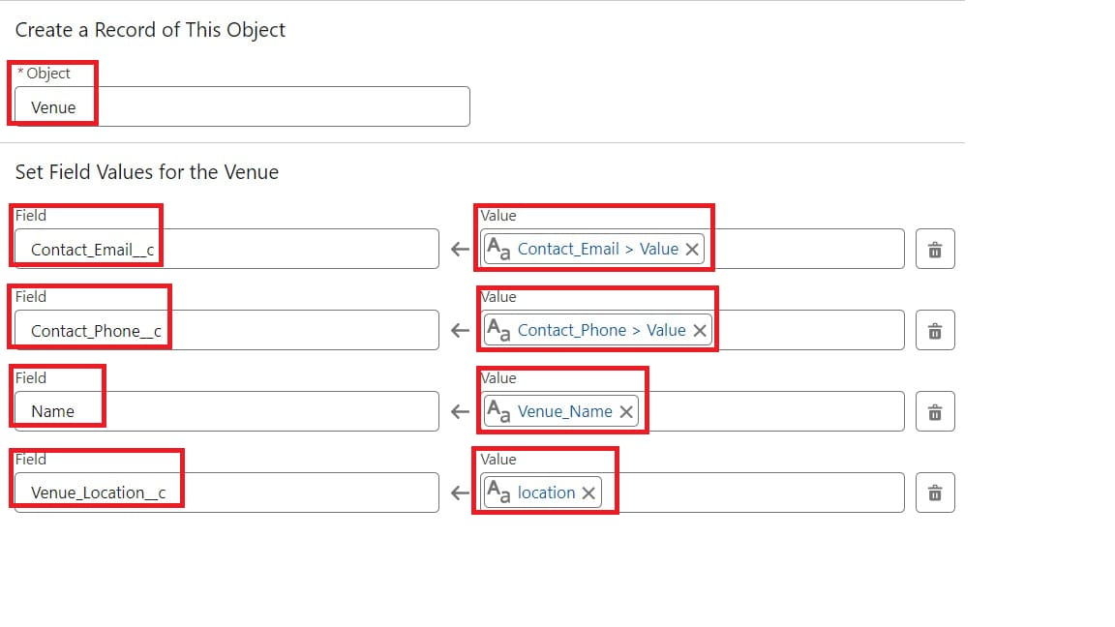

Trigger: Create a Trigger, Trigger Code

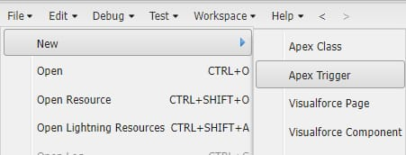

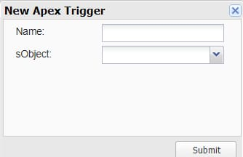

Create Profile

Creation of Users: Creation of Users1,2,3

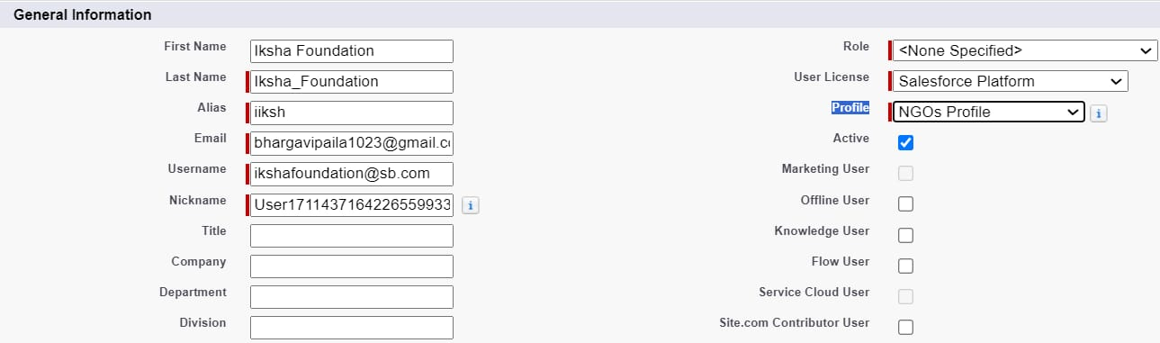



Public Groups: Creation of Public Group1,2

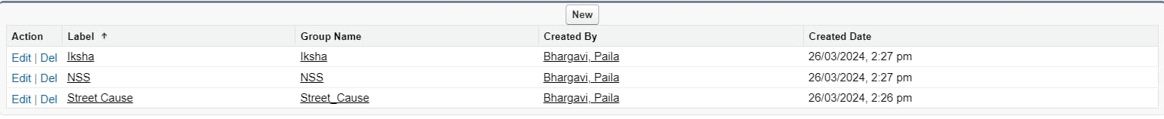

Report Types: Creation of Report Types

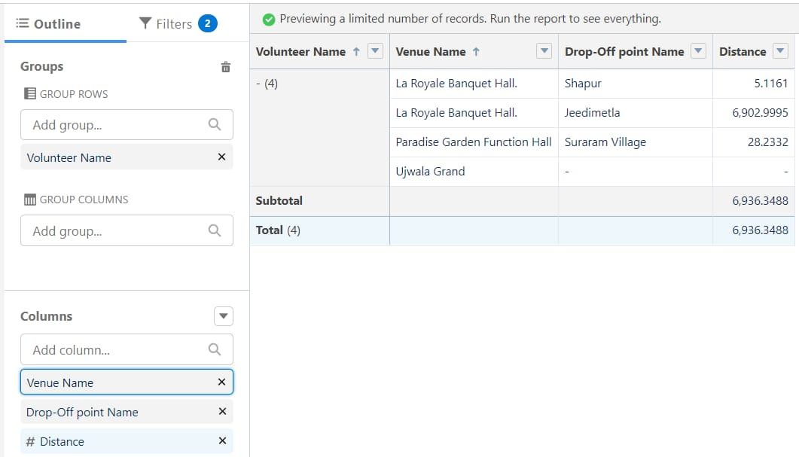

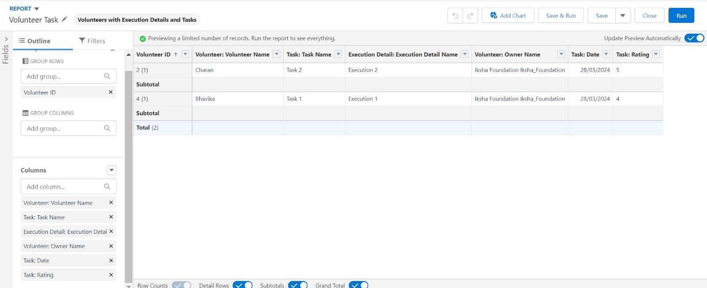

Dashboards: Adding Venue and Drop Off point Report to the Dashboard, Adding Volunteer Task Report to the Dashboard, Adding a picture to the Dashboard (Optional)

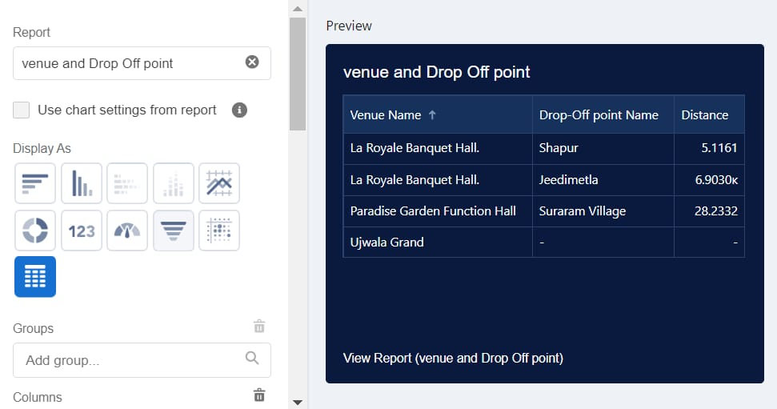

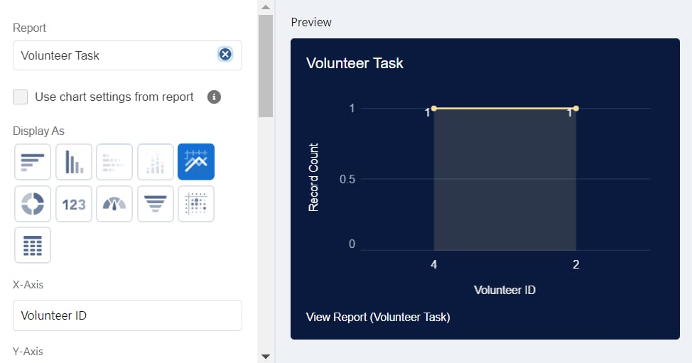

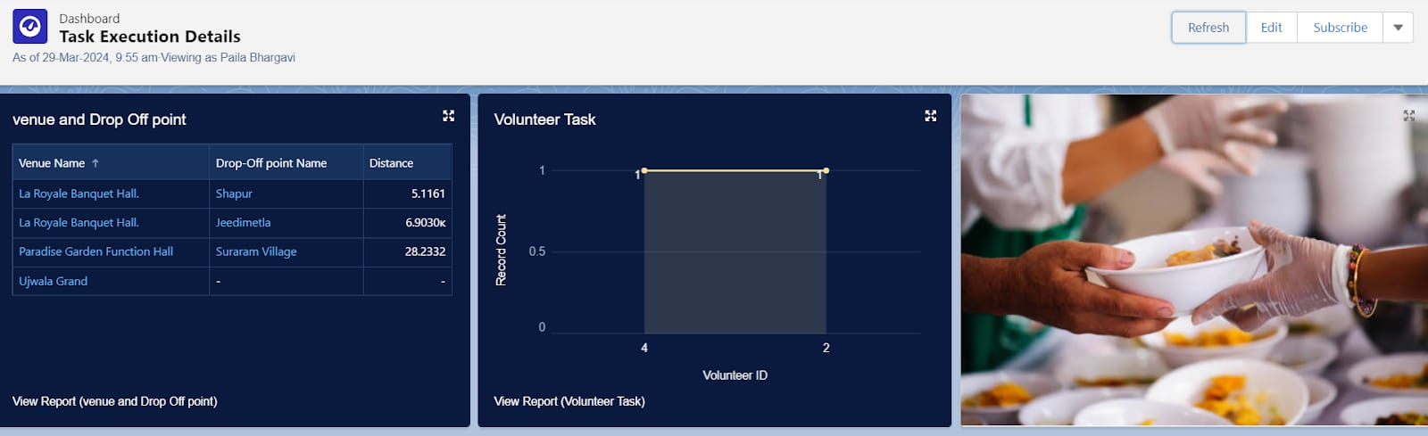

Sharing Rules: Creation of sharing rules

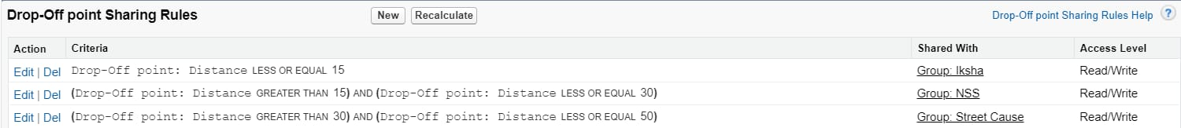

Home Page: Creation of Home Page

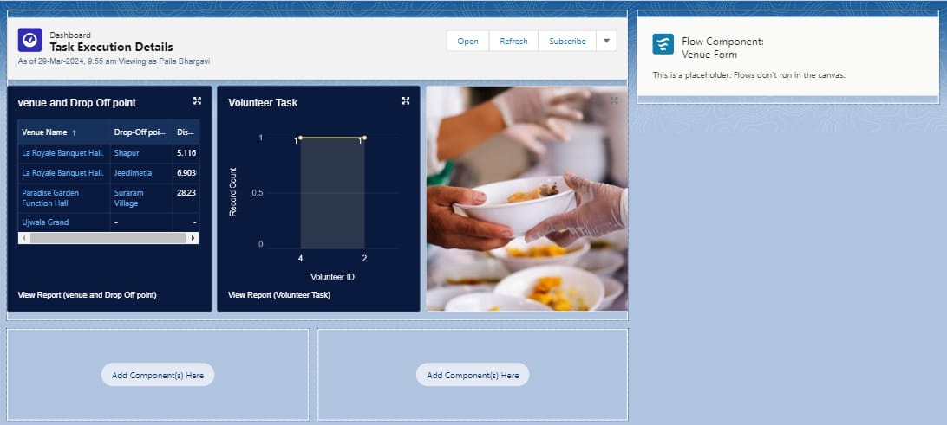

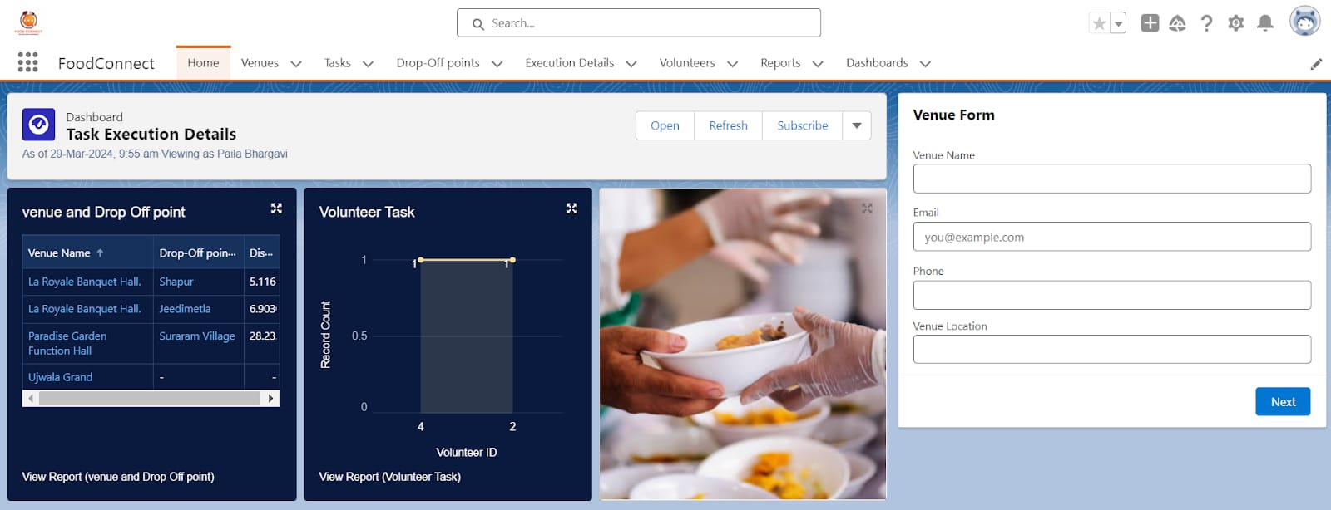

### ✅ **Conclusion for the Project: Supplying Leftover Food to the Poor**

This project aims to bridge the gap between food waste and hunger by collecting safe, edible leftover food from donors and redistributing it to those in need. By building partnerships with restaurants, hotels, households, and NGOs, the initiative not only provides relief to underprivileged communities but also promotes environmental sustainability by reducing food waste.

Through careful planning, legal compliance, and community involvement, this project can create a reliable and impactful system of food redistribution. With continued support and awareness, it has the potential to grow into a long-term solution that addresses hunger, fosters compassion, and encourages responsible consumption in society.

Ultimately, the success of this project lies in collaboration — proving that small contributions, when combined, can create a significant and lasting difference in the lives of many.

### ✅ **Advantages:**

1. **Reduces Food Waste**
   * Leftover food that would otherwise be thrown away gets used meaningfully.
   * Helps address the global issue of food wastage.
2. **Fights Hunger**
   * Provides meals to those who cannot afford to buy food.
   * Helps improve the nutrition and health of underprivileged communities.
3. **Promotes Social Responsibility**
   * Encourages individuals, restaurants, and companies to be socially responsible.
   * Builds a culture of sharing and caring in society.
4. **Environmental Benefits**
   * Reducing food waste also reduces the environmental impact (like methane emissions from landfills).
   * Saves the energy and resources used in food production.
5. **Cost-effective Charity**
   * It doesn't require extra food production—just better food management.
   * Can be a low-cost way for organizations and businesses to give back.
6. **Improves Public Image**
   * Restaurants, hotels, and corporates can enhance their public image through charitable

### ⚠️ **Disadvantages:**

1. **Food Safety Risks**
   * Leftover food can spoil easily, leading to health issues like food poisoning if not handled properly.
2. **Legal Issues**
   * Donors may fear being held legally responsible if someone gets sick from the donated food.
3. **Logistical Problems**
   * It can be difficult to collect, store, and distribute the food quickly before it goes bad.
4. **Inconsistent Availability**
   * Leftovers are unpredictable, making it hard to provide regular meals to those in need.
5. **Lack of Dignity**
   * Some recipients may feel disrespected or embarrassed receiving "leftover" food.
6. **Quality Concerns**
   * The food might not always be nutritious, fresh, or suitable for everyone’s dietary needs.
7. **Dependency Risk**
   * Relying too much on donated food may prevent long-term solutions to poverty and hunger.